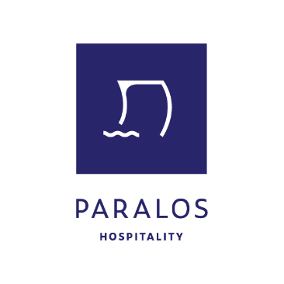
Paralos Hospitality, a dynamically growing hotel management company based in Heraklion, Crete, is seeking an experienced and highly organized Head of Central Reservations for a permanent, year-round position at its headquarters in Heraklion.
Key Responsibilities:
• Lead and coordinate the Central Reservations Department, ensuring excellent service and efficient operations.
• Manage and monitor the PMS (Protel) and booking engines (WebHotelier).
• Oversee the reservations process across all online platforms.
• Review and update prices, offers, and content on extranets, working closely with the Revenue Manager on strategic planning and online channel performance.
• Supervise room availability and allocation across all hotels.
• Collaborate closely with the Front Office Managers (FOM) of each hotel to ensure smooth reservation flow and handle special requests.
• Maintain and develop relationships with partner travel agencies and Tour Operators regarding reservations.
• Work alongside the Sales Department to monitor performance and develop initiatives to maximize results.
• Monitor statistics, analyze performance data, and implement improvement actions.
• Guide, train, and evaluate reservations supervisors and agents.
👉 This position reports directly to the Commercial Director of Paralos Hospitality under the supervision of the General Manager.
Required Qualifications:
• Minimum 10 years of experience as Head of Reservations (or equivalent role) in a large hotel or hotel group.
• Excellent knowledge of extranet management (Booking.com, WebHotelier, Expedia).
• Strong command of the English language (written & spoken). Additional languages will be considered an asset.
• Excellent use of PMS Protel, computers, and Microsoft Office.
• Strong leadership, organizational, decision-making, and strategic thinking skills.
• Team spirit, reliability, and professionalism.
We Offer:
• A competitive salary package based on qualifications and experience.
• Career development opportunities within a growing hotel group.
• A friendly and supportive working environment.
Location: Heraklion, Crete
Employment Type: Permanent – Full-time
If you match the profile we are looking for and wish to contribute to the continued growth of one of the most comprehensive and professional hospitality companies in the industry, please send your CV to: career@paraloshospitality.com

